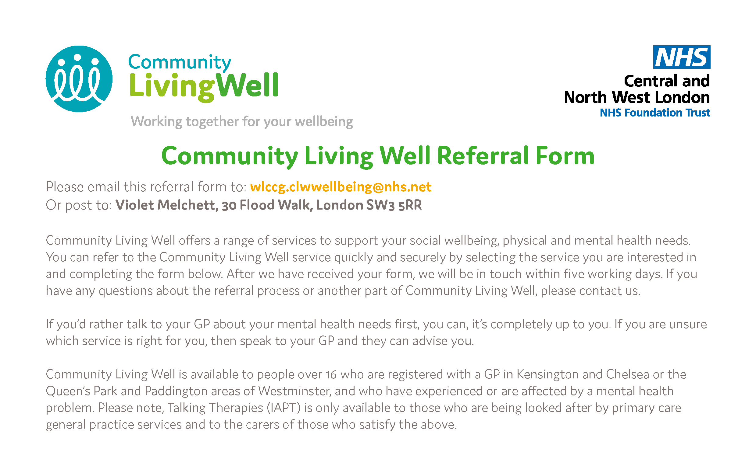
WHICH COMMUNITY LIVING WELL SERVICE WOULD YOU LIKE TO REFER YOURSELF TO?
☐ | Employment | Support to gain or retain paid employment, and improve employability skills through volunteering, training or education.
☐ | Navigators | Practical support with a range of issues including benefits, debt, housing options, access to health and social care services and support to access specialist advice and information.
☐ | Young Adult Navigator Service | A range of support to help 16-25 year olds manage their overall wellbeing including Information, Advice & Guidance, social prescribing, coaching/mentoring, action planning and access to specialised services. Ideal for those with unmet needs, low mood, low motivation, depression, anxiety, CAMHS leavers and care leavers.
☐ | Peer Support | Peer support groups, wellbeing workshops and activities with other people who have had similar experiences to you; organised to help improve your emotional wellbeing and resilience.

To refer yourself to Talking Therapies please complete the following online form: http://bit.ly/2CTNYnk. To be referred to Community Mental Health Hubs, you must speak to your GP.

DETAILS ABOUT YOU
Title (Mr, Miss, Mrs, Ms, Mx etc)
First Name:
Last Name:
Date of Birth: | D | D |  | / |  |  | M | M |  | / |  | Y | Y |  | Y |  | Y
What best describes your gender? | ☐ Female
 | ☐ Male
 | ☐ Prefer not to say
 | ☐ Prefer to self-describe:
Email address:
Can we email you?: | ☐ Yes |  |  |  | ☐ No
Address:
POSTCODE:
Can we write to you at your address?: | ☐ Yes |  |  |  | ☐ No
Telephone No:
Can we leave a message on your phone?: | ☐ Yes |  |  |  | ☐ No
Please tell us the best way to contact you
Do you require a translator or counselling in another language? | ☐ Yes |  |  |  | ☐ No
If yes, what language?
GP Practice
GP Name
Please briefly explain your difficulties and if there is a part of the Community Living Well service you are most interested in.

Referrer Details
(if you are completing this form on behalf of someone else, please give your details)
Title (Mr, Miss, Mrs, Ms, Mx etc)
First Name:
Last Name:
Job title:
Service name:
Telephone number:
Email:

Please email referral to: wlccg.clwwellbeing@nhs.net
Referrals can also be posted to: Violet Melchett, 30 Flood Walk, London SW3 5RR

