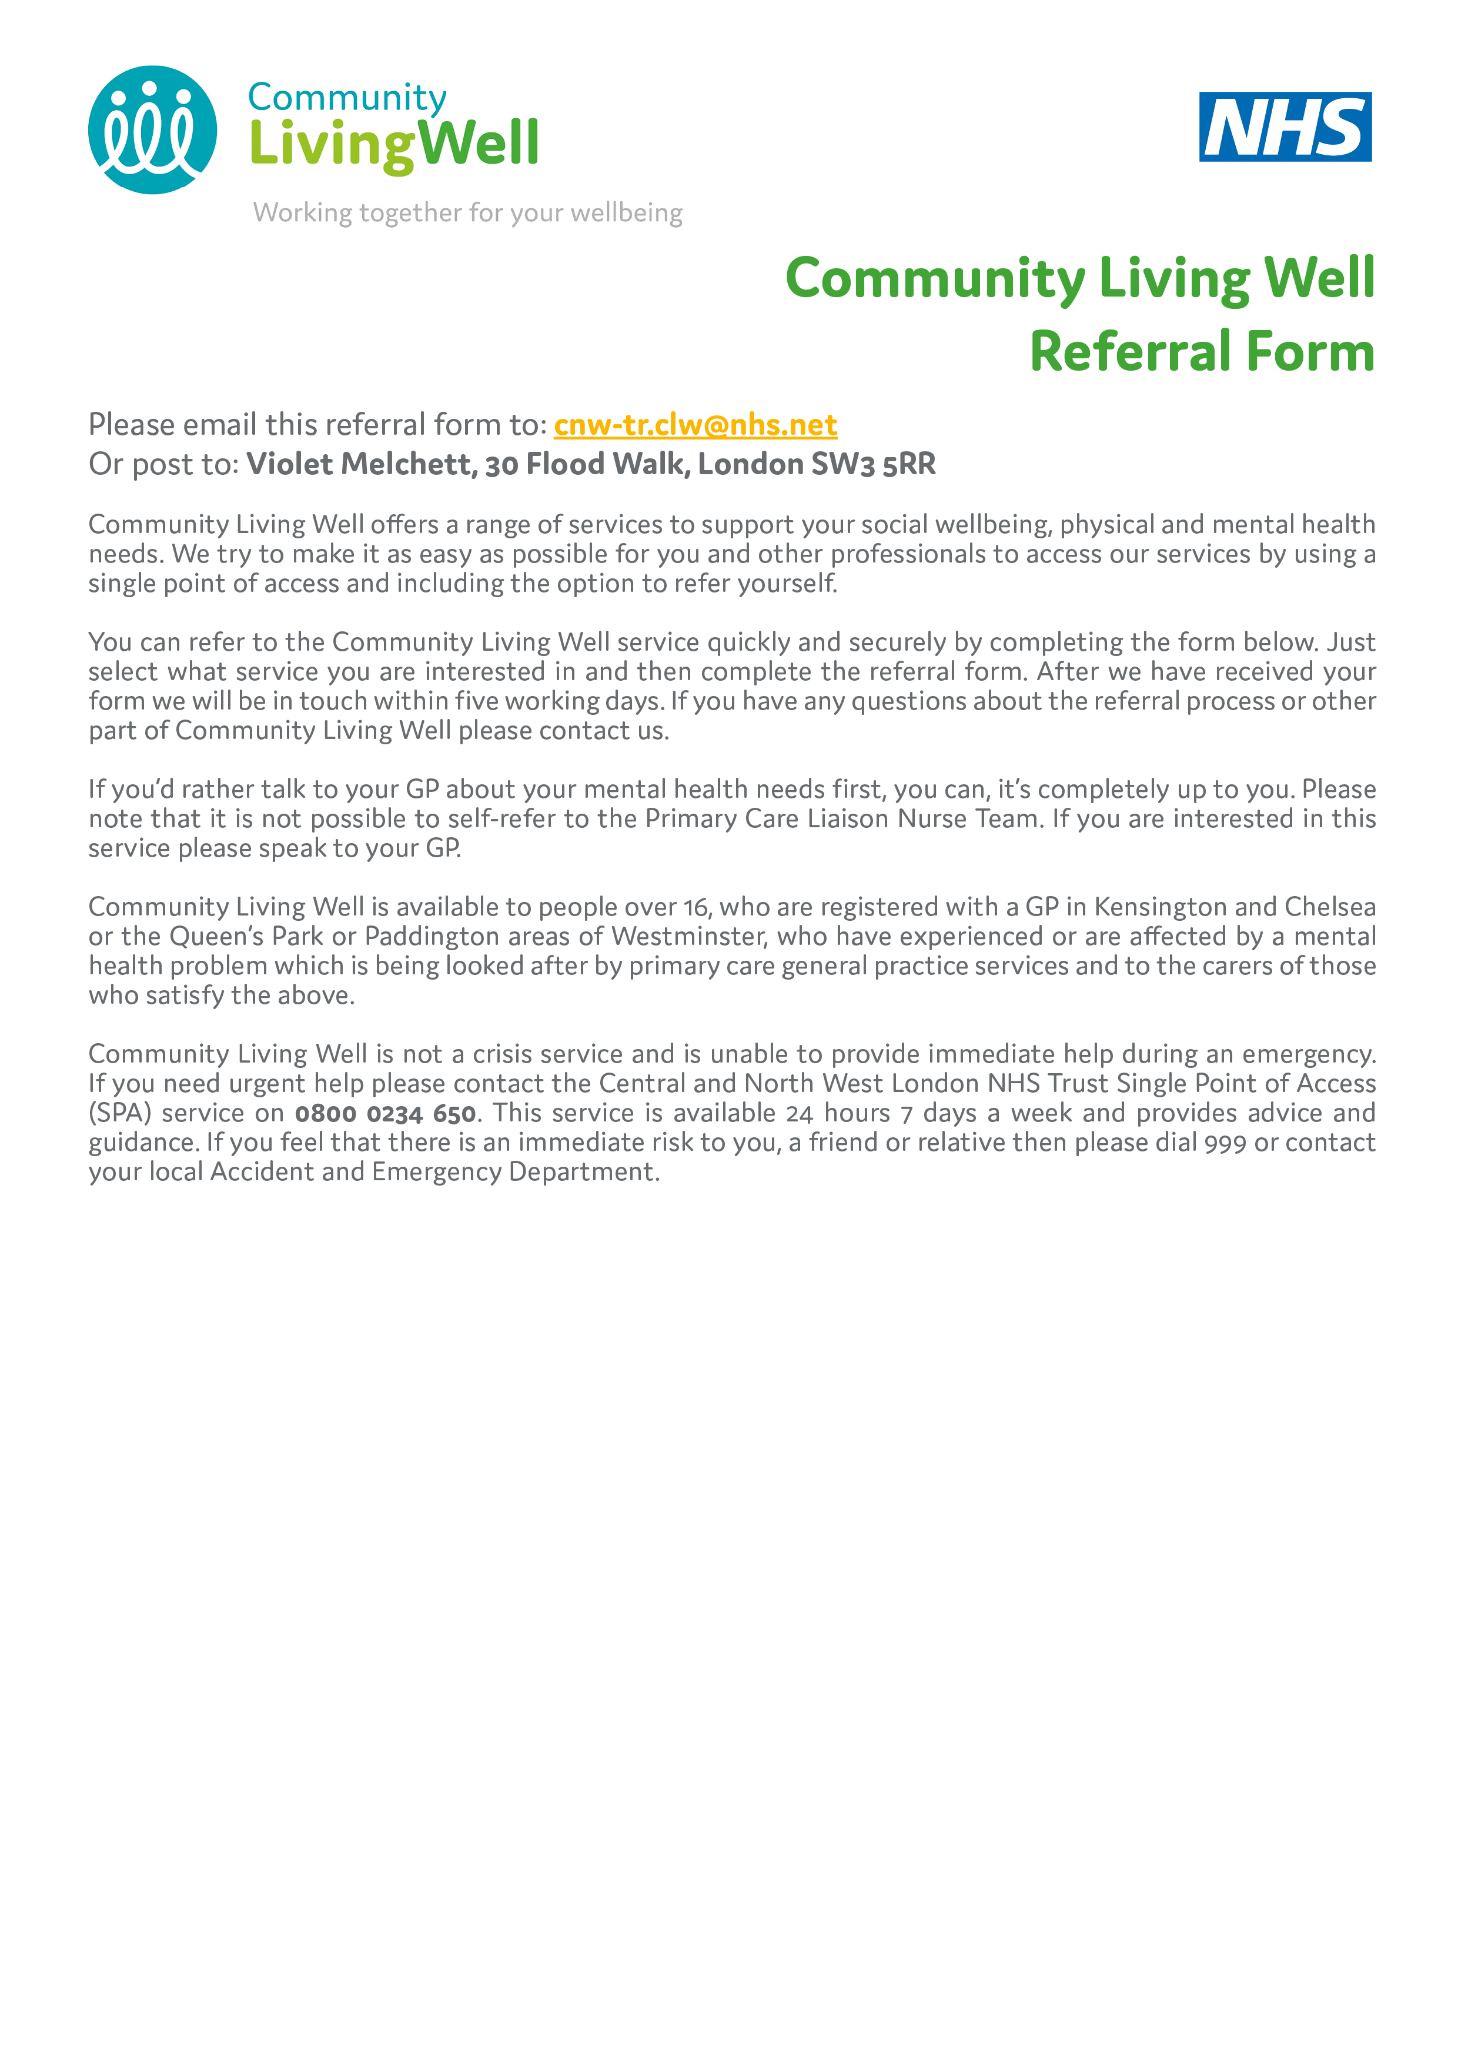

WHICH COMMUNITY LIVING WELL SERVICE WOULD YOU LIKE TO REFER YOURSELF TO?
☐ | Employment | Support to gain or retain paid employment, and improve employability skills through volunteering, training or education.
☐ | Navigators | Practical support with a range of issues including benefits, debt, housing options, access to health and social care services and support to access specialist advice and information.
☐ | Peer Support | A range of group and one-to-one support to improve social, emotional, and practical skills and resilience, by people with lived experience.

To refer yourself to Psychological Therapies or Mother Tongue Counselling please complete the following online form: http://bit.ly/2CTNYnk. To be referred to a Primary Care Liaison Nurse you must speak to your GP.

DETAILS ABOUT YOU
First Name:
Last Name:
Date of Birth: | D | D |  | / |  |  | M | M |  | / |  | Y | Y |  | Y |  | Y
What best describes your gender? | ☐ Female
 | ☐ Male
 | ☐ Prefer not to say
 | ☐ Prefer to self-describe:
Email address:
Can we email you?: | ☐ Yes |  |  |  | ☐ No
Address:
POSTCODE:
Can we write to you at your address?: | ☐ Yes |  |  |  | ☐ No
Telephone No:
Can we leave a message on your phone?: | ☐ Yes |  |  |  | ☐ No
Please tell us the best way to contact you
Do you require a translator or counselling in another language? | ☐ Yes |  |  |  | ☐ No
If yes, what language?
GP Practice
GP Name
Please briefly explain your difficulties and if there is a part of the Community Living Well service you are most interested in.

